Cabarrus Partnership for Children’s
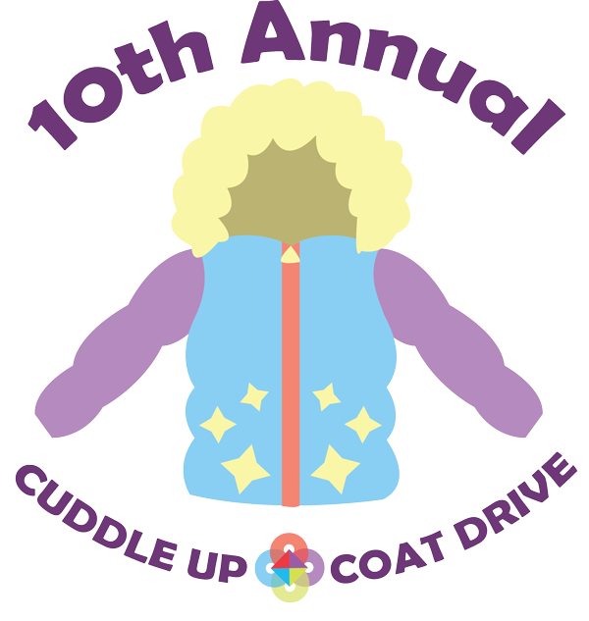

Join us once again this year in collecting new and gently loved winter coats for children in Cabarrus County!
Want to Donate?
- New or VERY gently loved children’s coats, sizes 12 months
up to size 10
- Preschool sized gloves & hats
- NEW packages of preschool sized socks and underwear

See the reverse side for drop box locations
Contact Elizabeth at (704)933-8278 ext.107 or elizabeth@cabarruspartnership.org for more details.
Find us on Social Media to keep up with the latest information!
Facebook.com/CabarrusPartnershipForChildren
Instagram.com/cabarruspartnership
Cabarruspartnershipnc.blogspot.com
Pinterest.com/CabarrusPFC

You can drop off your donations at any of these community locations:

Cabarrus Partnership for Children
1307 S. Cannon Blvd, Kannapolis, NC 28083

All Saints Episcopal Church
525 Lake Concord Rd. NE, Concord, NC 28025

Country Law Shack
5605 Hwy 49, Mount Pleasant, NC 28124

First Presbyterian Church of Concord, Fellowship House
70 Union St. N, Concord, NC 28025

Nationwide Insurance Kelley Moulton Agency
250 Church St NE, Concord, NC 28025

STARS Preschool at Crossroads Church
220 George W. Liles Pkwy, Concord, NC 28027

The Sunshine House
3056 Weddington Rd NW, Concord, NC 28027

UNC at Chapel Hill Nutrition Research Institute
500 Laureate Way, Kannapolis, NC 28081

