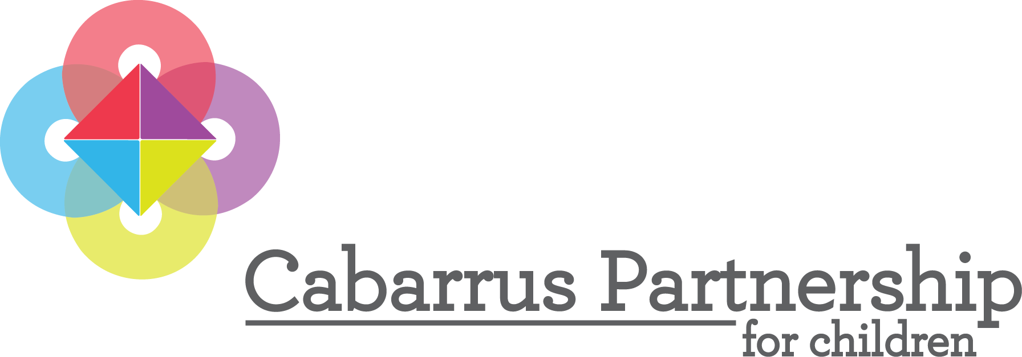

The Cabarrus County Partnership for Children
Requests for nominations for the
2025 Anne Laukaitis Champion for Children Award

The Anne Laukaitis Champion for Children Award is in honor of Anne’s distinguished Smart Start leadership and her long career dedicated to the service of young children and families in Cabarrus County. This award is given annually to an exceptional individual at the local level who is devoted to public service and whose leadership qualities have resulted in significant change for the improvement of young children, families, and communities. Among the leadership qualities the recipient will exemplify are:

- Passionate commitment to the vision of a stronger community for children and families.
- The ability to lead and inspire others in pursuit of that vision.
- Personal integrity, humility, and professional will.
- Willingness to work hard, stay the course even in the face of adversity, and acknowledge the contributions of others.

- An unbridled and optimistic pursuit of possibility.

The 16th Annual Anne Laukaitis Champion for Children Award will be given at the 2025 Annual Meeting/Voices for Children Luncheon of the Cabarrus County Partnership for Children (CCPC) Board of Directors on Tuesday, December 2, 2025, at McGill Baptist Church Sanctuary at noon. The recipient will be honored and will receive a plaque of thanks at the meeting. The family of the recipient will be invited to the Annual Meeting/Voice for Children Luncheon to share in the award presentation.

Nomination Procedures

Who can make nominations? Nominations for the Anne Laukaitis Champion for Children Award can be submitted by anyone that works and serves in Cabarrus County. The nominee must have worked to improve the lives of young children in Cabarrus County and exemplifies the above-mentioned leadership qualities.

When is the deadline for award nominations? Nominations must be emailed to Ann Benfield at ann@cabarruspartnership.org or mailed (P.O. Box 87, Kannapolis, NC 28082-0087) by 5:00 p.m. on Friday, October 24, 2025.

Who will review the nominations? The nominations will be reviewed by CCPC board of directors or the appointed Nomination Review Committee.

Who should I call if I need additional information? Please call Ann Benfield 202-297-4733 email at ann@cabarruspartnership.org with any questions regarding the nomination or award.

2025 Anne Laukaitis Champion for Children Award
Nomination Form

Nominator Information

Name:

Mailing Address:

City: Zip Code:

Phone Number: Fax:

Email:

Nominee Information

Name:

Mailing Address:

City: Zip Code:

Phone Number: Fax:

Email:

Agency/Organization (if applicable):

Narrative

Share your personal testimony of what makes this individual deserving of the Anne Laukaitis Champion for Children Award. Please limit your narrative to no more than two pages. In writing your narrative, emphasize the following:

- Describe how the individual’s leadership qualities have made a difference on behalf of young children, families and communities.
- What has changed in your community or across the state on behalf of young children and families as a result of this individual’s leadership?
- Share a story that depicts his/her long-term leadership, commitment, and passion to making a difference on behalf of young children and families.

