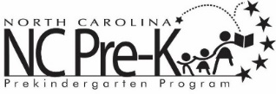

Cabarrus County Preschool Programs
Health Services Agreements

Cabarrus County Preschool Programs require continuous healthcare for all students so they are healthy and ready to learn. As a condition of enrollment in this program,

I agree to the following for
(child's name)

- I will take my child to their healthcare provider for a well-child visit every 12 months and provide the school with a copy of the physical and shot record each year.

- If my child's vision is not screened during the well-child visit, I agree to have their vision screened by school staff. I agree to complete all follow-up appointments deemed necessary related to my child's vision.

- If my child's hearing is not screened during the well-child visit, I agree to have the school audiologist screen their hearing. I agree to complete all follow-up appointments deemed necessary related to my child's hearing.

- I agree to pick up my child if any of the following occur:
  - Vomiting- child must be free of vomiting and without medication for 24 hours before returning to school
  - Diarrhea- child must be free of diarrhea and without medication for 24 hours before returning to school
  - Fever- 100 degrees or higher, child must be fever free without medication for 24 hours before returning to school
  - Lice- live bugs, will be sent home with the 14-day treatment sheet, and must see the nurse before returning to class, after initial treatment
  - Other- See parent handbook for a list of other conditions/diseases that require exclusion from school

Parent signature: _ Nurse signature: _
Date: _____
Date: _____

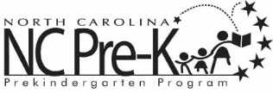

Consent for Photograph, Filming, or Taping of Children

I give permission for my child to be filmed, taped or photographed by the Cabarrus Partnership for Children, NC Pre-K, Cabarrus County Schools, Kannapolis City Schools and/or Department of Human Services.

The film, tape, or photograph will be used for educational, informational purposes and public awareness at the discretion of the Partnership for Children. The primary purpose is to share the community information affecting young children and their families. These services are funded by Smart Start.

Thank you for allowing your child to be an example of how Smart Start is raising the awareness of the community to children's needs.

Child’s Name: ____________________________________________

Parent’s Name: ____________________________________________

Staff Signature: ______________________________________ Date:____________

