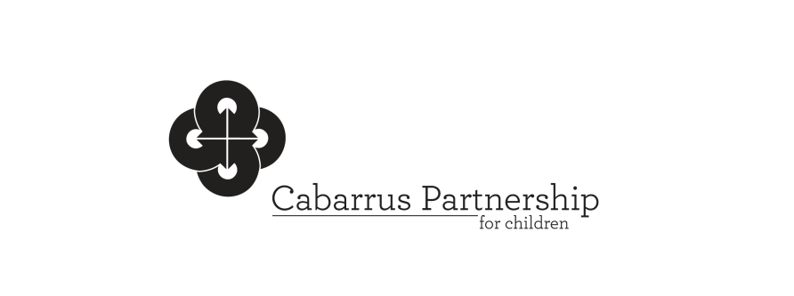

**NC-Pre-Kindergarten (NC Pre-K)/Early Education Committee Meeting**

July 23, 2025

11:00 a.m.

**Welcome and Introductions** Ann Benfield

Establish Quorum

**Action Items**

* Minutes of May 21 and 23 2025 Ann Benfield
* Budget/Slot Allocation Update

**NCPK Updates**

* Committee Roles and Responsibilities Patricia Sehorn
* Application, Screening and Enrollment
* Staffing

**Other Agency Reports**

* Smart Start Updates Ann Benfield
* DHS Subsidy Updates Elizabeth Heston
* CCRI Starr Batts
* CCS Trina Wenzel
* KCS/HS Erin Anderson Jennifer Baucom

Wynter Sexton

* RCCC Amanda Martin
* Endless Opportunities Lashonda Houston
* P.U.R.E Excellence Waynett Taylor
* Cabarrus County Libraries Hoke Pittman Jordan Maddux

**Next Meeting**

**January 21, 2026**

**10:00**