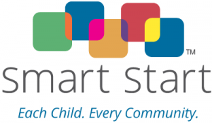
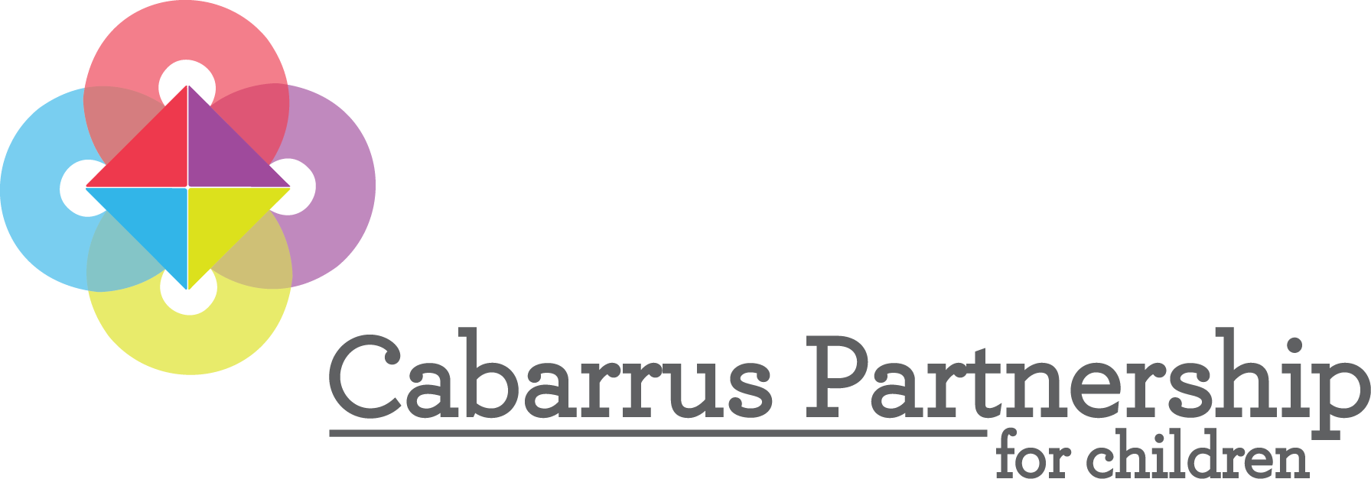
FY2019-2020 and FY 2020-2021 Proposal Application
Due May 28, 2019 – 5:00 p.m.
Applicant Information: (Click and type to complete each blank.)
Name of organization: Click or tap here to enter text.
Name of activity: Click or tap here to enter text.
Address: Click or tap here to enter text.
County, City and Zip: Click or tap here to enter text.
Contact Person for application: Click or tap here to enter text.
Phone: Click or tap here to enter text. Fax: Click or tap here to enter text.
Email: Click or tap here to enter text.
Legal and tax-exempt status:
☐501(c)(3) organization(non-profit) ☐Government ☐Community Based ☐Institution of Higher Education
Years organization in operation: Click or tap here to enter text.
Does your organization have a board of directors? If yes, provide a listing of current board members
☐ Yes ☐ No
Explain any possible conflict of interest that may exist between the applying entity, its staff, officers or directors
and the Partnership. Click or tap here to enter text.

List other expected funding sources for this program. Click or tap here to enter text.

Complete if NEW Applicant only: (fill in blanks) Click or tap here to enter text.
Attach the most current audited financial statement. If a current audited financial statement is not available, please explain:
Click or tap here to enter text.

Complete if CURRENTLY FUNDED Applicant Only: (fill in blanks)
Number of years this program funded by the Partnership: Click or tap here to enter text.
Do you plan to change the scope, staffing, or any other key factors in your activity? ☐Yes ☐No If yes, please describe in detail: Click or tap here to enter text.

Signatures of Chief Executive Officer and Board member authorized to sign on behalf of the Board: Signature indicates Board approval of the request and willingness to comply with Smart Start Application Agreement.

Signature Date

Print Name and Title

Signature Date

Print Name and Title

HAVE YOU COMPLETED AND ENCLOSED:
ALL APPLICANTS NEW APPLICANTS ONLY
☐RFP Application (including signatures) Attachment A ☐Three (3) letters of support
☐RFP Attachment B (Excel workbook – separate attachment) ☐Written Guidelines (if available)
☐PID selection tab ☐Most recent audited financial statement
☐Logic Model tab (2 yrs)
☐Detailed and Narrative Budget tab (2 yrs)
☐Summary budget tab (this will auto populate)
☐Job descriptions of funded and in-kind staff
☐List of Board of Directors (if applicable)
☐Research/Articles (if not in NCPC EB/EI guide, then required)
☐Other optional materials
APPLICATION NARRATIVE – Please answer each item below.
Page limit for Narrative should not exceed 9 pages – Do not change font size
- Contract Activity Description (CAD): Include the service activity description in 400 words or less including: (a) what need is being addressed, (b) what service will be provided, (c) for whom the service will be done, (d) who will provide the service, (e) where it will be done, and (f) when it will be done. Applicants must complete a summarized activity description (abstract).
Click or tap here to enter text.

- Activities funded with Smart Start dollars must be Evidence-Based or Evidence Informed. Check below if the proposed activity fits either description. The EB/EI Guide is available at www.cabarruspartnership.org.
☐Evidence Based ☐Evidence informed
If this activity is listed in the NCPC EB/EI Guide, identify the program name or element and page number of the guide it is located on: Click or tap here to enter text.
If not, state the source that rates evidence-based programs that the activity is listed in and describe how the activity is evidence-based or evidence informed. (Please include full research article(s) with application.)
Click or tap here to enter text.
If NEW Applicant only: Provide written activity guidelines (if they are available) and documented evidence that your program has a record of success (this can be in the form of data summary reports).

- Describe the relevant education, experience and credential requirements for positions funded by Smart Start or counted as a Smart Start match. If your activity uses a model for implementation include the staff requirements for model fidelity. Please note that Level 11 Certification is required for child care-related activities. For other activities, a bachelor’s degree in a Human Service or related field is preferred. Attach job descriptions of funded or in-kind match staff.
Click or tap here to enter text.
Is training and professional development related to this program or practice readily available? Is training culturally sensitive?
Click or tap here to enter text.

- Describe how your activity will be marketed to participants to ensure participation and increase awareness of the activity’s availability.
Click or tap here to enter text.
How will you ensure your program is inclusive of all populations?
Click or tap here to enter text.
Does your program address issues of race equity, cultural responsiveness or implicit bias? Please provide examples.
Click or tap here to enter text.

- Describe the collaborations necessary to implement this activity. Include organizations and agencies that have collaborated in the development or delivery of your service.
Click or tap here to enter text.

- Will this activity include grants, stipends, or scholarships of any kind (refer to budget line items 45, 46 and 47 in Excel workbook)?
☐Yes ☐No
If YES, explain what they are and why these are necessary for the successful delivery of the activity.
Click or tap here to enter text.

- Please list ALL materials that are intended to be given away free of charge to participants in your program and the intended purpose of those materials.
Example: Healthy Families Manual for families attending training w/exercises in manual
Click or tap here to enter text.

- Do you have an evaluation method in place to track services? If so, what service tracking system do you use and what measurement tools do you use to collect feedback on services and to improve practices?
Click or tap here to enter text.

- Complete logic model in Attachment B (which includes needs statement, target population, activity elements, outputs, outcomes and long term outcomes). If elaboration is needed for activity service elements, describe below in full what specific services you will be implementing. What specific services/tasks will be done and by whom? Describe how and where the service will be delivered (e.g. center-based, home visiting, mobile unit).
Click or tap here to enter text.
Which Partnership priorities does this program address (substance abuse, mental health, obesity)?
Click or tap here to enter text.
If the program or any program element is similar to other activities in Cabarrus County, please list those and explain how your service differs or will enhance, expand or work with other similar services being currently offered.
Click or tap here to enter text.

