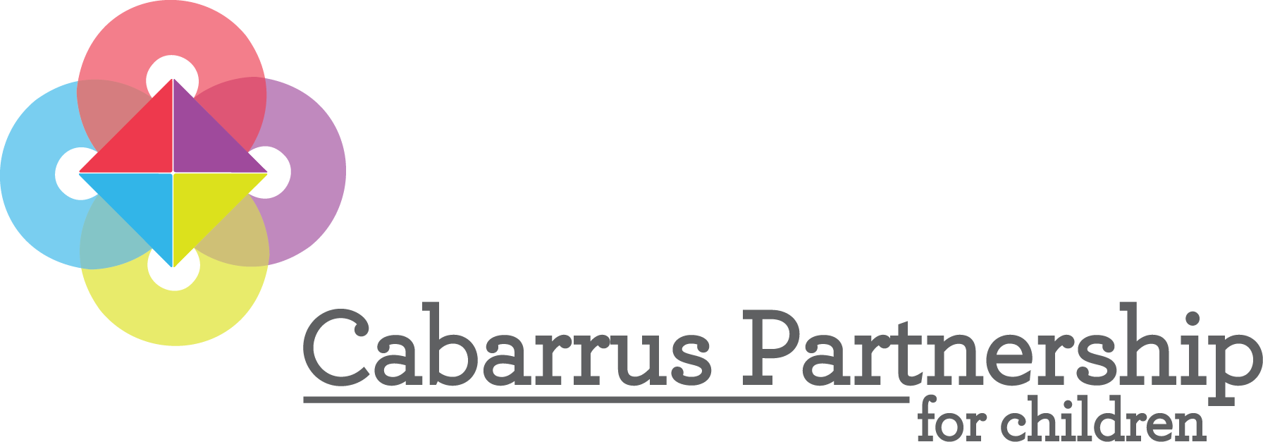
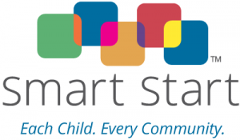

Request for Proposals
FY2019-2020 and FY2020-2021

The Cabarrus County Partnership for Children, Inc. (CCPFC) is seeking qualified organizations with expertise in early childhood to support our local community with evidence-based or evidence-informed services for children birth to five and their families to provide the following programs:
- Parents As Teachers
- Attachment Bio-behavioral Catchup
- Early Education Liaison – will address teacher education in Cabarrus County. This position will serve as a liaison between the community college system and child care facilities in Cabarrus County and be responsible for managing and conducting communications with students concerning their enrollment and retention.
RFA Release Date: | May 10, 2019
Submit Questions to: | Lauren Westin  lauren@cabarruspartnership.org
Deadline to submit questions: | Tuesday, May 21, 2019 – 5:00 p.m.
Deadline for Proposals: | Tuesday, May 28, 2019 – 5:00 p.m.
Submit to: | Attention: Lauren Westin
Electronic Submission: | lauren@cabarruspartnership.org
Mailed or Hand Delivered to: | 1307 South Cannon Boulevard  Kannapolis, NC 28083
Applicant presentations to grant review committee: | Tuesday, June 18, 2019, if needed. Time and location to be determined.
Grant Award notices: | After June 25, 2019 CCPFC Board meeting, no later than July 2, 2019

Applications should be submitted both in hard copy and electronic format no later than the time listed above. Late applications will not be accepted. Faxed applications will not be accepted.
I. GENERAL INFORMATION
Introduction
Smart Start is North Carolina’s nationally recognized and award-winning early childhood initiative designed to ensure that every young child living in North Carolina enters school healthy and ready to succeed. The Cabarrus County Partnership for Children is the local non-profit organization that administers Smart Start funds in Cabarrus County. We collaborate with existing programs and support the creation of new ones to measurably strengthen families and improve the lives of children.
The Cabarrus County Partnership for Children (hereinafter referred to as the “Local Partnership”) is soliciting proposals to establish a contract through a competitive process. The purpose of this Request for Application/Proposals (RFA/RFP) is to acquire the services of qualified programs (hereinafter referred to as the “Contractor”) to support our local community with evidence-based or evidence-informed services for children birth to five and their families.
Purpose of the Request
Experiences during early childhood literally shape the structure of the brain. Because today’s children are tomorrow’s leaders everyone has a stake in making sure that all children have the experiences they need to thrive. Providing support to the programs and people who are involved in a young child’s life—families, teachers, doctors, caregivers, social workers, and many others is a way to ensure every child has all they need for healthy growth and development.
The Local Partnership is seeking proposals from programs that are interested in providing services that support the quality and availability of early childhood services that address the needs of children from birth to age five, their families and/or caregivers specifically around the Local Partnership’s priorities of substance use, mental health, and obesity.
Priorities are based on the following community-based needs:
- Early Care and Education – Quality and Early Care and Education – Workforce: Increasing the quality of infant/toddler early care and education. (Roughly 38% of our County’s infants and toddlers do NOT receive high quality early care.)
- Family Support: Family-focused programs that improve parenting and promote involvement. Some ways these can help ensure children’s success are: parent education programs that give parents tools to increase their knowledge of early childhood development and positive parenting practices, as well as home visiting programs to help new parents and parents-to-be by providing education, information and resources.
- Health: Increasing prenatal and infant/toddler access to healthcare and working with providers, health departments, families, and communities to improve the health and safety for young children (19% of children in Cabarrus County enrolled in Medicaid are NOT receiving well-child visits), increase healthy weight (34% of Cabarrus children are NOT at a healthy weight), and ensure that more children are screened for developmental delays and referred to services for help before they start school.

II. AVAILABLE FUNDING AND ELIGIBILITY REQUIREMENTS
Award Term and Requirements
Funding for this project is provided for a two-year term and is contingent on funding availability and adherence to the requirements of the grant. The term of any resulting award is anticipated to be for two fiscal years 2019-2020 and 2020-2021. (From July 1, 2019 until June 30, 2021) In addition:
- The bidder must submit annual budgets ending June 30th with its proposal. Contracts for subsequent fiscal years in the multi-year bidding period will be executed only after a satisfactory evaluation of performance, availability of funds, and review and approval of proposed activities.
- Funds may not be used for goods or activities that are currently funded by other government sources to ensure no supplantation of funds.
- A projected 19% in kind program match is required that may include, but is not limited to, parent and community volunteer time, donations of goods and services, etc.
- A background check of each person providing direct services to children under the contract will be required at the expense of the Direct Service Provider in accordance with the Partnership’s policy.

If the proposal is approved for funding, the applicant must agree to the following pre-contracting documents:
- Work collaboratively with the Local Partnership and across agency lines in a community context.
- Regularly disclose that the activity receives funding from Smart Start and the Local Partnership.
- Be available for monitoring visits and meetings held by the Local Partnership.
- Comply with fiscal, program and evaluation reporting requirements and deadlines.
- Revert funds not spent by the end of the fiscal year, unless requested to do so prior to that date.
- Understand that funds must be spent according to the North Carolina Partnership for Children (NCPC) Cost Principles [found at www.cabarruspartnership.org). If contract terms are not met, funds may be discontinued and any unspent funds returned to the Local Partnership.
- Comply with NCGS 143C-6.2 reporting requirements https://www.ncleg.net/EnactedLegislation/Statutes/HTML/BySection/Chapter_143C/GS_143C-6-23.html
- Participate in any audit/evaluation of the Partnership that is required by the NC General Assembly or any other State officials/agencies.
- Maintain the necessary fidelity bond and commercial liability insurance coverage required.
- Return items purchased with Smart Start funds should the entity no longer perform the services for which the assets were purchased.
Eligibility
Eligible applicants include non-profit, government agencies, community-based organizations and institutions of higher education with experience in delivering services to children, their families and child care professionals.
All proposals must impact children from birth through age five. Programs directed at children older than five cannot be considered, by legislative mandate. Only Evidence-Based/Evidence-informed Programming will be accepted. Level 11 Certification is required for child care-related activities. For other activities, a bachelor’s degree in a Human Service or related field is preferred.

To be eligible to apply for this funding, applicants must demonstrate sound organizational and fiscal capacity. Funds should be used for activities, experiences, or other resources that have a beneficial impact on children and follow Smart Start legislative mandates and Cost Principles. A copy of the Smart Start Cost Principles is available at www.cabarruspartnership.org.
In addition, eligible applicant’s programs must be located in Cabarrus County. This is to ensure that applicants and their providers have a strong understanding of our community’s needs and assets while having established relationships with other stakeholders.

The prospective Contractor must provide details of any pertinent judgment, criminal conviction, investigation or litigation pending against the prospective Contractor or any of its officers, directors, employees, agents or subcontractors of which the contractor has knowledge, or a statement that there is none. The Local Partnership reserves the right to reject a proposal based on this information.

Selection Process
All applications received by the required deadline will be reviewed to ensure all necessary attachments and documentation are complete and included. Applications that are incomplete, late, or submitted by non-eligible applicants will not be reviewed by the grant review committee. Nothing may be added to any application after it has been submitted, including a signed certification page. Complete applications from eligible applicants will then be forwarded to the grant review committee who will review, score and rank the applications. A copy of the scoring criteria is available at www.cabarruspartnership.org.
Applicants may be required to make a 15-minute presentation to the grant review committee of the Partnership Board on June 18, 2019 to briefly describe their activity and answer specific questions. Presentation times, if needed, will be scheduled after June 10, 2019.
The grant review committee (Program Oversight Committee) will meet to formulate recommendations to the full Board. Committee members will not include any representative who may have a conflict of interest regarding any funding decision.

Award notices will be provided after the June 25, 2019 Cabarrus County Partnership for Children Board meeting, no later than July 2, 2019.

The grant review committee will be recalled IF funding levels made by the General Assembly are not adequate to fully meet the approved program budgets.

III. SUBMISSION INSTRUCTIONS

Application Format
Applications (proposals) must include the following components to be considered complete and responsive for funding. All documents are available at www.cabarruspartnership.org. Incomplete applications (proposals) will not be reviewed or scored:
ALL APPLICANTS NEW APPLICANTS ONLY
☐RFP Application (including signatures) Attachment A ☐Three(3) letters of support
☐RFP Attachment B (Excel workbook) ☐Written Guidelines (if available)
☐PID selection tab ☐Most recent audited financial statement
☐Logic Model tab (2 yrs)
☐Detailed and Narrative Budget tab (2 yrs)
☐Summary budget tab (this will auto populate)
☐Job descriptions of funded and in-kind staff
☐List of Board of Directors (if applicable)
☐Research/Articles (if not in NCPC EB/EI guide, then required)
Basic format:
- The application should be completed in the Proposal Application document and printed on 8 ½ x 11 inch white paper. Font sizes of responses should not be changed.
- Respond to each criterion in the order listed in the Application Narrative.
- Page limit of the Application Narrative section, not including first 2 pages of application and attachments, is 9 pages. Reviewers will not consider material past the page limit in the printed report.
- One (1) signed original and eight (8) copies should be submitted via mail or in person.
- An additional electronic submission should be sent to lauren@cabarruspartnership.org.
Application Deadline
ALL APPLICATIONS MUST BE RECEIVED BY 5:00 P.M. ON MAY 28, 2019. Applications that are hand-delivered by applicants, couriers, by overnight/express mail couriers, or other representatives of the applicant must be received on, or before, the due date listed. Applications must be delivered between the hours of 8:30 a.m. and 5:00 p.m. ET, Monday through Friday (excluding holidays) and delivered to:
Cabarrus County Partnership for Children
Attn: Lauren Westin
1307 South Cannon Boulevard
Kannapolis, NC 28083

Questions and Answers
All questions must be submitted in writing (email preferred to lauren@cabarruspartnership.org)
Technical Assistance
- All questions must be submitted in writing by the deadline listed for questions. No questions will be responded to verbally.
Additional Requirements Upon Selection
If your proposal is selected, the Local Partnership will contact you (the Contractor) to obtain information and documentation required for preparation of the contract. Please note, these requirements are for your information only and DO NOT need to be included in your application. They include the following:
- Name; title; telephone and fax numbers; and mailing address, including street address and zip code, of the contract administrator.
- If a nonprofit entity, a copy of the Internal Revenue Code § 501(c)3 determination letter received from the IRS.
- No Overdue Taxes Certification.
- Board of Directors list (if a 501(c)3).
- Bylaws (if a 501(c)3).
- Proof of insurance that may include, but not be limited to, the following:
  - Workers’ compensation;
  - General business liability;
  - Professional liability;
  - Fidelity bonding (e.g., employee crime or dishonesty);
  - Automobile (owned, hired or non-owned).
- Completed Internal Revenue Service (IRS) Form W-9.
- Most recent audit report and/or financial statements.
- The Local Partnership will not contract with any prospective Contractor that fails to provide all required information and documentation. After all required information and documentation has been submitted, the Local Partnership will prepare the contract, notify the selected Contractor and submit the contract for signature. A template of the Contract that the selected Contractor will be required to sign is available upon request.
- The Contract must be executed prior to the start of work and incurring any expenses.
- If all proposals are rejected, prospective Contractors will be notified promptly by the Local Partnership.

